S/N A01408

NOVASEQ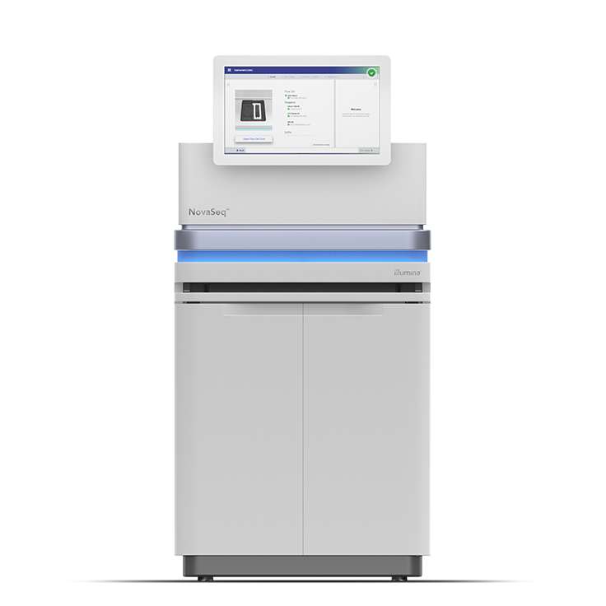

PRO 20522422